Dalwhinnie Community Action Plan:
Looking to 2030
Compiled Summer 2023
Supported by
Dalwhinnie Community Council
Dalwhinnie Community Development Trust
Dalwhinnie Village Hall
Dalwhinnie Businesses
Facilitated by Voluntary Action in Badenoch and Strathspey
Dalwhinnie Community Action Plan: Looking to 2030
Page 1 of 17

Contents
1
2
3
4
5
6
7
8
9
. Summary
3
. The Community
. The Process
4
5
. Community Engagement
. Survey Responses
. Action Plan – what the community wants
. Next Steps
8
8
9
13
15
16
. Thanks
. Appendices
i. What do you like about living in Dalwhinnie?
ii. What changes would you like to see for Dalwhinnie by 2030?
Dalwhinnie Community Action Plan: Looking to 2030
Page 2 of 17

1
. Summary
In Spring 2023, Dalwhinnie Community Council, together with Dalwhinnie Community
Development Trust, Dalwhinnie Village Hall and Dalwhinnie businesses (The Apiary,
Dalwhinnie Service Station, Balsporran Guest House, Dalwhinnie Hostel), decided that they
wished to carry out a review of the community action plan for the village, which had been
previously undertaken in 2009. The purpose of revisiting and updating the plan was primarily
aimed at giving these key community organisations, along with a range of other groups in the
village, plus public and private sector stakeholders, a strong mandate to move forward with
tackling current and emerging issues, as well as leading on new community projects, identified
as priorities by the residents and businesses of Dalwhinnie during the process in spring 2023.
With support from Voluntary Action in Badenoch & Strathspey, the community-led steering
group, comprising representation from the organisations listed above, agreed that they would
seek the views of local residents and businesses on a number of key questions. This was
achieved via a survey which was personally delivered to every household by volunteers - as a
paper copy, which was also accessible online. In addition, the questions contained in the survey
were also raised with some targeted groups that were identified as being harder to get
accurate/quality information from. This was undertaken by members of the steering group
going out with the survey questions to places and events where it was considered that
individuals or groups falling into this category might be approached.
The process was entitled Dalwhinnie Community Action Plan: Looking to 2030. In
previous action planning carried out by the community, the focus was on activity mostly lasting
up to a 5-year span. Given the increased need now to also focus on longer-term goals,
particularly in relation to the environment and the economy, residents and businesses were
asked to consider where they and the community wanted to be by 2030, so generating, more
or less, an 8-year set of plans and aspirations.
Examples of Dalwhinnie’s recent successes with community projects and action planning
include:
1
2
3
4
5
6
7
8
9
. Improvements/Activities at the Village Hall
. Café in the village
. Better water quality & supply & screening
. More trees planted
. Better (visitor) information via Dalwhinnie.org
. Winter lights upgraded
. More dog fouling bins
. Old café demolished
. Recycling area cleaned up
To help add to these achievements, residents were encouraged to take part in the community
action plan review in 2023. However, this time round people were invited to think not only
about what might be achieved together, but that the projects the village was being asked to
consider, would be ones that would help Dalwhinnie develop a more sustainable future. This
Dalwhinnie Community Action Plan: Looking to 2030
Page 3 of 17

is set against a backdrop of life post-Covid, the challenge of finding new volunteers plus the
changing economic and climate situation we find ourselves in.
The Dalwhinnie community action planning process adhered to the National Standards for
Community Engagement to ensure all of the following elements were fully taken into account
during the community-led initiative:
Impact, Communication, Methods, Working together, Planning, Support and Inclusion.
See Section 4. Community Engagement for further details on the 7 Standards.
2
. The Community
Dalwhinnie is a small village of around 80 people, situated at the southern end of Badenoch,
at an altitude of 351m, near the foot of Ben Alder. It lies in a glen with the Monadhliath
Mountains on one side and the Forest of Atholl, the Cairngorms and the Grampians on the
other. Its wide, open wilderness provides a healthy environment that residents value highly
and also encourages many visitors to return to the area year after year. Dalwhinnie is
recognised as one of the coldest villages in the UK, having an average annual temperature of
6
.5°C, which makes it ideally suited to winter walking and mountaineering. This special
natural environment also allows for a wide variety of other recreational activities such as
mountain biking, fishing and white water kayaking which serve to attract the many tourists
that pass through the village in the summer months.
Distinguished as having the highest working distillery in Scotland, Dalwhinnie is steeped in a
rich history created over many generations. The population of this settlement is small, yet
actively committed to community life, maintaining a strong sense of independence partly
owing to their ‘bracing’ geographic location.
Dalwhinnie enjoys close links with the Ben Alder Estate which provides a mainstay of
employment for the area and the estate’s sustainable approach to managing the surrounding
landscape is highly regarded by the local population. Residents are aware that their local
amenities are limited and vulnerable and in response to these particular issues, Dalwhinnie
would like to see new housing initiatives introduced, which will allow young families to
move into and remain in the area long term. Better transport links to other communities
both north and south of the village, are seen as additionally necessary to improve
Dalwhinnie’s chances of remaining a viable ‘lived in’ community, providing work and leisure
opportunities to help it thrive as a location of choice.
New initiatives are continually being taken forward by committed community members,
such as the refurbishment and activities at the village hall, better facilities and information
for visitors to encourage them to stay longer in the village and ongoing care for the
environment, both in and surrounding the community. These are just some of the ways in
which the residents themselves feel they can help to support the fragile tourist trade and
consequently the ongoing future wellbeing of the village.
Dalwhinnie Community Action Plan: Looking to 2030
Page 4 of 17

Community Organisations
There are a number of community organisations/groups which work for the benefit of the
community and are almost entirely run by volunteers. These include:
Dalwhinnie Community Council, Dalwhinnie Community Development Trust and Dalwhinnie
Village Hall amongst others.
Community Assets
Village Hall
Village website
Local Businesses
There are numerous local businesses, across many sectors, operating in the village, although
there is currently no local business/tourism association to represent the commercial activity
in the village.
Dalwhinnie businesses include the whisky distillery, hotel, hostel and self-catering
accommodation, garage, food and gift outlets. These, along with a number of tradespeople,
farmers, people employed on estates and carrying out other kinds of environmental work,
make up the working heart of this community.
3
. The Process
The Dalwhinnie community consultation period ran from March to June 2023 and during
this time, the way in which the community action planning process was carried out, broadly
fell into four stages. These were:
1
2
3
4
) Gathering Information
) Data Sorting and Collation
) Involving People & Refining Ideas
) Community Action Plan (CAP) document production
Within the four stages of the process, the following questions were asked by the steering
group.
Gathering Information
⋅
⋅
⋅
⋅
What do we want to know?
What questions will we ask?
What methods will we use?
How will we do it?
Data Sorting
⋅
⋅
⋅
⋅
What does it involve?
How will we do it?
Who will do / assist with this?
In what form will we present it back to the community?
Dalwhinnie Community Action Plan: Looking to 2030
Page 5 of 17

Involving People & Refining Ideas
⋅
⋅
⋅
⋅
What stakeholder groups do we need to involve?
How (& where) will we present the information gathered so far?
How will people in the community help refine the information?
Who will assist with this?
CAP document production
⋅
⋅
⋅
⋅
What will it include?
Who will put it together?
How will it be presented to the community?
What happens to it next?
In addition, the steering group also considered what timescales and key dates they wanted
to aim for and how they would deal with communications & publicity - ensuring that these
elements were robust, so the process was as inclusive as it could be.
The fifth and most crucial stage of the whole action planning initiative, involves delivery of
the plan by the Dalwhinnie community and other stakeholders. Essentially this deals with
questions such as:
⋅
⋅
⋅
Who will take responsibility for the CAP?
How will it be driven forward?
How will it be monitored and evaluated?
There is more detail on how this can be achieved in Section 7. Next Steps.
Gathering Information
There was a lot of discussion about the nature and precise wording of questions in the
survey, as the steering group wanted to revisit questions asked in previous community-led
action planning, to re-establish what specific things people liked about Dalwhinnie and
wanted to keep in the community. They also wished to encourage the community to look
to an 8 to 10-year horizon, and consider how it might tackle some of the trickier issues
such as care for the environment, supporting younger and older residents, employability and
transport. So questions were employed which were broadly framed, to allow responders to
bring up a wide range of issues and ideas without being led.
The paper version covered just two sides of A4 and the survey asked 3 questions:
1) What do you like about living in Dalwhinnie?
2
) What changes would you like to see for Dalwhinnie by 2030?
(Perhaps consider how as individuals, or as a community, we can improve the environment, address the
climate emergency, develop our local economy, increase social and leisure opportunities and widen local
cultural experiences)
If you could improve just ONE of these things, what would it be?
) Are there any new projects (large or small) that you would like to see happening in the
community? Or any existing projects that need to be sustained?
3
The survey also asked:
Would you be willing to get involved in any projects you are interested in? YES / NO
If Yes, please provide contact details.
Dalwhinnie Community Action Plan: Looking to 2030
Page 6 of 17

This last additional question was included to try to encourage more people to come
forward to help with projects that were of particular interest to them, in order to
counteract the reduction in volunteer numbers, that had come about in recent years and
especially following the pandemic.
It was decided that all 50 households would receive a paper copy of the survey through
their letterbox and this was carried out by a team of community volunteers, who over a
period of a few days, delivered copies out into the community. This method helped to
deliver an inclusive process of community engagement, where everyone had the opportunity
to respond to the survey if they wished and they were able to do this via hard copy, which
could be deposited back into one of the centrally located survey boxes, or online via QR
code which enabled the community to access the survey on a range of devices.
Data Sorting
All of the responses came in either online via Survey Monkey, by hard copy into CAP-branded
boxes left at locations in the village, or from information collated at events put on for specific
groups in the village. Surveys were returned from the community’s school pupils and these
responses highlighted the ideas and opinions of young people living in the area.
Every comment was recorded and categorised, so that everyone would be able to ‘see’ their
voice in the displayed results. The information was sorted into 3 main themes: Social,
Environmental and Economic and the number of times a particular issue or idea was
mentioned was noted, so priorities could rise to the top of the lists in each themed category.
These lists were then prepared for display (see Section 6. Action Plan – what the community
wants and Section 9. Appendices), so every member of the community could see what had
been said and get involved in the next stage, when ideas were refined and solutions to issues
sought.
Involving People & Refining Ideas
The process culminated in Dalwhinnie’s Big Conversation, which took place during an
evening in June 2023 at the Dalwhinnie Village Hall. At this drop in event, the results were
offered back to the community and time given for reflection and discussion around the
topics. During the event, all of the residents who attended were asked to consider the top
priorities that had been identified from the process under the headings of Dalwhinnie:
-
-
-
A Socially Connected Community
A Climate Conscious Community
An Economically Thriving Community
They were asked to look at those areas of particular interest to them and write on action
plan templates aimed at refining ideas by looking at questions such as: What specific action
needs to be taken to achieve this priority and Who needs to be involved?
CAP document production
All of the comments and pieces of information given by the public during the Big
Conversation event were collected and incorporated into this report, which now belongs to
the Dalwhinnie community and will be used as the basis for ongoing community
Dalwhinnie Community Action Plan: Looking to 2030
Page 7 of 17

development in the village over the next 10 years, with support from the community’s
organisations and all other relevant stakeholders from the public, private and voluntary
sector.
Also a list of all those who came forward offering to volunteer their help with certain
projects was compiled and will be held by the team taking the action plan forward (referred
to as Team Dalwhinnie for the purposes of this report).
4
. Community Engagement
The National Standards for Community
Engagement are good-practice principles
designed to improve and guide the
process of community engagement.
They are clear principles that describe
the main elements of effective
community engagement. They provide
detailed performance statements that
everyone involved can use to achieve the
highest quality results and the greatest
impact.
The standards are particularly helpful for
communities - their organisations and
groups - to help them involve their
members or the wider community in shaping the services and changes they need, and to
make sure they accurately represent members' or the community’s views in the decision-
making processes.
5
. Survey Responses
Thanks go to the 34 residents and businesses in Dalwhinnie who contributed so meaningfully
and thoughtfully to the community survey – this number represents 42% of the community’s
population and includes responses from school age residents. Also to the people who
attended the Big Conversation drop-in event at the village hall.
For a full list of what came out of the survey responses, see Section 9. Appendices (list of
appendices below). These show all comments made by the community in answer to the survey
questions, prioritised in order of the number of people who mentioned them.
Appendix i What do you like about living in Dalwhinnie?
Appendix ii What changes would you like to see for Dalwhinnie by 2030?
Dalwhinnie Community Action Plan: Looking to 2030
Page 8 of 17
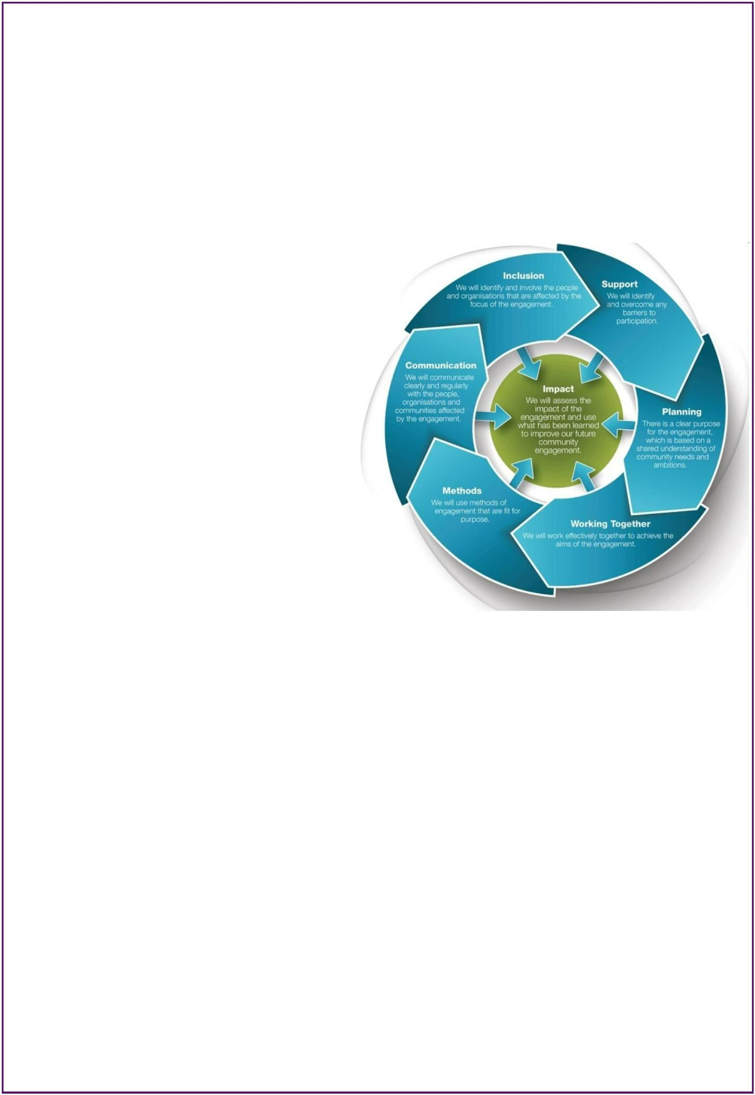

6
. Action Plan – what the community wants
Project Themes and Priorities
The CAP sets out the community’s vision for the longer term (up to 10 years) with more
detailed activity across the 3 specified themes:
-
-
-
A Socially Connected Community
A Climate Conscious Community
An Economically Thriving Community
itemising priority outcomes and actions which are shown in the relevant tables below.
It is important to note that some of the project outcomes will be a “quick win” whereas
others will sometimes take significantly more time to plan and execute. To achieve results
and outcomes in the short, medium/longer term each high priority project/outcome will have
its own activity plan which will be Specific, Measurable, Achievable, Realistic and Timely
(SMART) and determined and agreed in the first part of the CAP implementation.
The 3 themes were taken and put into separate groupings, showing what the priorities are
for each theme. Within each priority, projects have been listed that have been drawn from
the high priorities that came out of the survey data. Further views and information for each
priority were sought from those who attended the drop-in events and suggested actions,
together with any additional information are outlined below each section.
Dalwhinnie Community Action Plan: Looking to 2030
Page 9 of 17
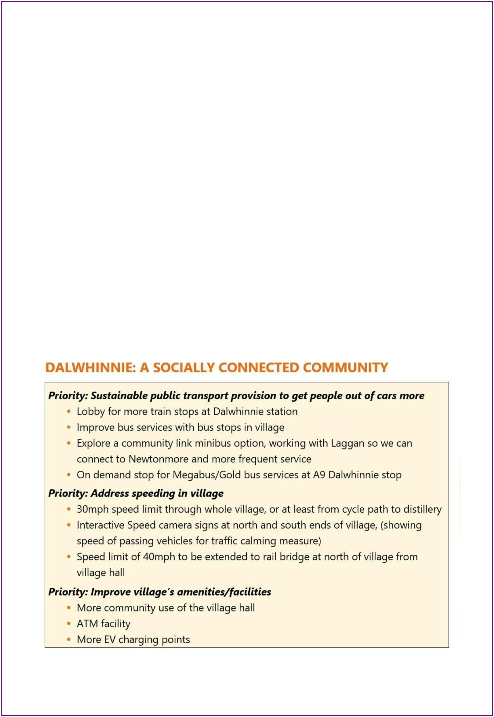

PRIORITY: SUSTAINABLE PUBLIC TRANSPORT PROVISION
Continue lobbying for better provision of bus & train services for the community
•
•
More train stops
Investigate bus services in village and with Megabus
Explore a community link minibus option, working with Laggan so we can connect to
Newtonmore and more frequent service
•
See if Laggan organisations would be willing to try and get a joint project going for both
communities’ benefit
PRIORITY: ADDRESS SPEEDING IN THE VILLAGE
0mph speed limit through whole village, or at least from cycle path to distillery
3
Interactive Speed camera signs at north and south ends of village, (showing speed of passing
vehicles for traffic calming measure)
Speed limit of 40mph to be extended to rail bridge at north of village from village hall
•
Community Council to work with Police, PKC and others to implement as many of these
traffic calming measures as possible (including ‘police’ mannequin)
PRIORITY: IMPROVE VILLAGE’S FACILITIES / AMENITIES
More community use of the village hall
•
•
•
Offer taster sessions of different activities including talks?
Increase facilities to enable locals to enjoy more / different activities in the hall
Provide internet connection
ATM facility
•
Explore if this is something one of the local businesses might offer
More EV charging points
•
Work with PKC and CNPA to increase coverage in the area
Dalwhinnie Community Action Plan: Looking to 2030
Page 10 of 17

PRIORITY: REDUCE ENERGY CONSUMPTION AS A VILLAGE / FOR
HOUSEHOLDS
Local green waste recycling plot for locals’ garden waste
•
Investigate viability of this initiative – contact similar projects in Highland/CNP/Scotland
to see what’s involved in potentially setting up
Advice on household fuel alternatives
•
Investigate advice/support available – set up an information event at hall for local
residents and businesses to drop in. Work with Laggan CC who want to do similar.
Turn off street lights to create a dark skies destination
•
•
Talk with other communities who have gone this route eg Tomintoul
Get advice from CNPA and PKC on possibilities
PRIORITY: IMPROVE VILLAGE’S VISUAL APPEARANCE
Keep village tidy and litter free (Main St, behind RSG yard, behind garage)
•
•
Reduce number of signs around village where possible
Tidy up garage, Green Shed site, road verges
More planting in village: trees, shrubs and flowers
•
•
Plant wild flowers and bulbs
Replace damaged young trees along main road
Dalwhinnie Community Action Plan: Looking to 2030
Page 11 of 17
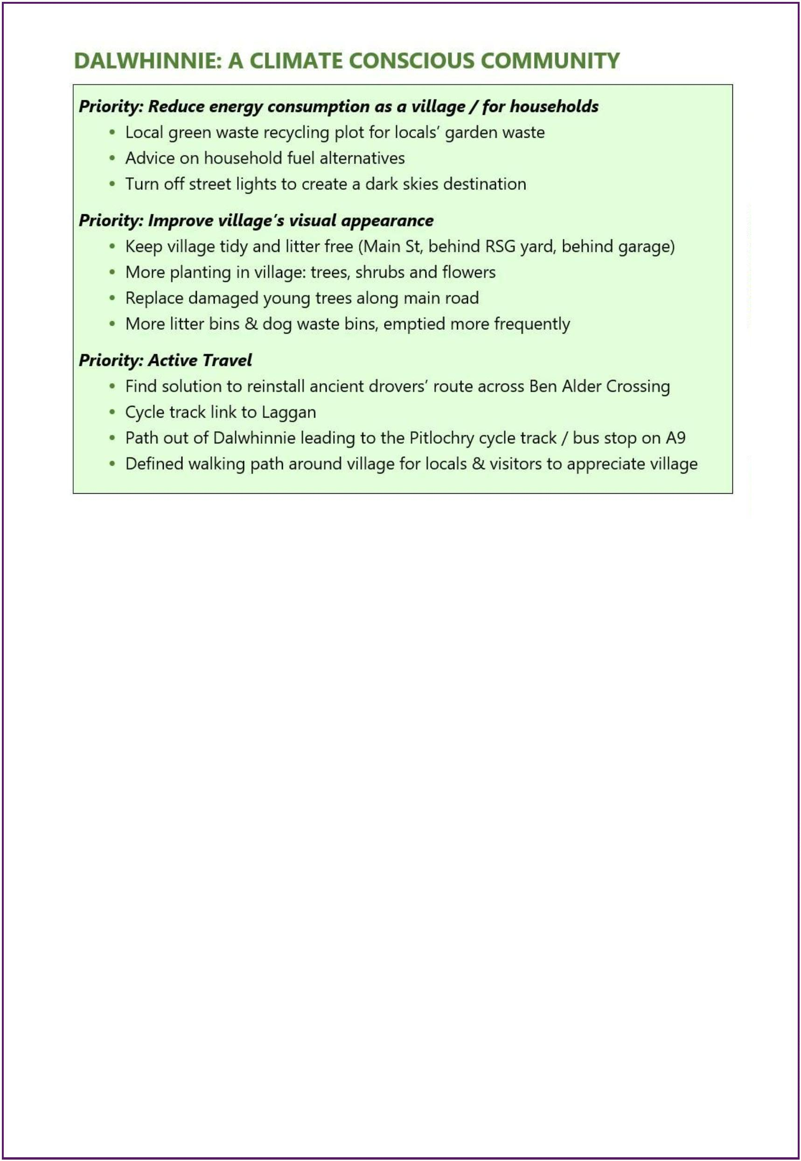

More litter bins & dog waste bins, emptied more frequently
PRIORITY: ACTIVE TRAVEL
Find solution to reinstall ancient drovers’ route across Ben Alder Crossing
Cycle track link to Laggan
•
Talk with CNPA and Laggan Active Travel group, to explore possibilities
Path out of Dalwhinnie leading to the Pitlochry cycle track / bus stop on A9
• Create a cycle lane between garage and existing Route 7
Defined walking path around village for locals & visitors to appreciate village
• Explore with landowners and get support for path routes from them and community
PRIORITY: INCREASE OPPORTUNITIES TO ATTRACT TOURISM &
BUSINESS TO LOCAL AREA
Set up a local business forum to support businesses in the village
•
•
Bring local businesses together to see what form of group might work best to benefit all
Agree on scope of any forum and what its key purposes are eg mobile bank visit,
tourism signage on A9, parking facilities in village
Dalwhinnie Community Action Plan: Looking to 2030
Page 12 of 17
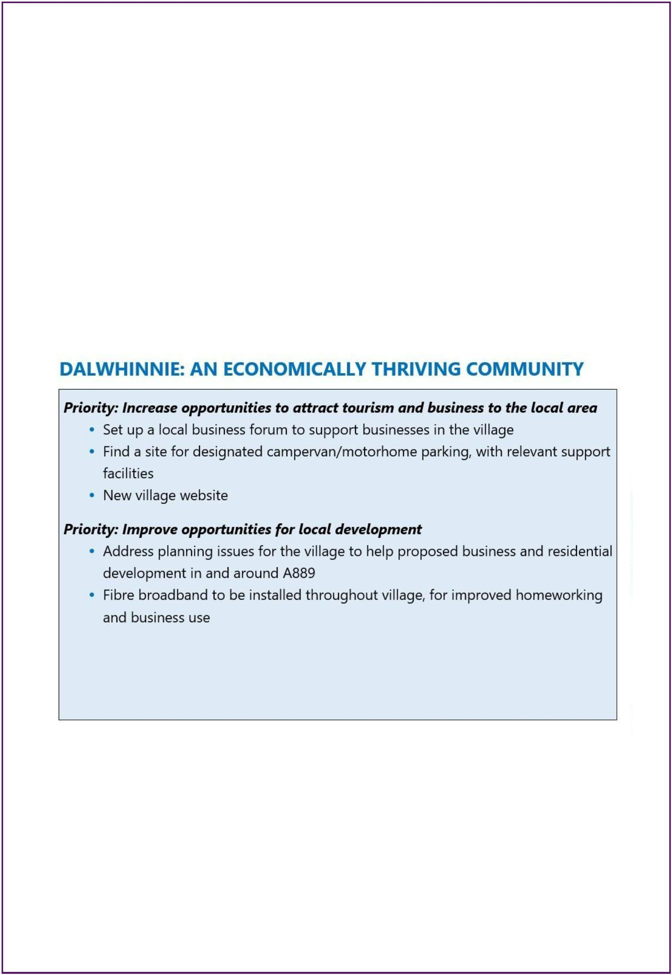

Find a site for designated campervan/motorhome parking, with relevant support facilities
•
Talk with community and CNPA planning re Local Development Plan about possible
sites and facilities
New village website
•
Seek support from partners to access funding and be informed on best practice to
develop a new website
PRIORITY: IMPROVE OPPORTUNITIES FOR LOCAL DEVELOPMENT
Address planning issues for the village to help proposed business and residential
development in and around A889
•
Engage with CNPA and THC planners together, to resolve the issues that are
contributing to planning being denied for development of housing and business use
Fibre broadband to be installed throughout village, for improved homeworking/business use
•
Investigate options and potential funding routes
7
. Next Steps: Delivery
Steps to deliver the Dalwhinnie Community Action Plan
The next steps to start working with the action plan and looking at how parts can start to be
delivered will be subject to some discussion within Dalwhinnie’s community organisations,
but broadly involves collectively:
•
Setting up a Team Dalwhinnie (see below) to take the plan forward. Agreeing a chair for a
specified period at a time, so will rotate after X months or after X meetings
Agreeing to adopt the Values and Principles laid out below
Agreeing what priorities will be taken forward initially
Managing the project volunteer list that has come out of the process
Involving all key stakeholders (organisations & individuals) in co-design of project delivery
Drawing up a more detailed delivery action plan for each prioritised project, identifying
aims, actions, milestones, who needs to be involved, key deliverables. (VABS has a
template for this.)
•
•
•
•
•
•
•
•
Communicating progress with the community
Reviewing progress on a regular basis
Revisiting the action plan as required
Values and Principles
The following values and principles will underpin the way in which this action plan is rolled
out and implemented:
1
) A plan for all - it is the responsibility of the whole community (individuals and groups)
to unite and work together for project ambitions to be realised
2
) Transparency - all ideas should be planned and researched openly with a commitment
to co-production where groups contribute to the ideas as they develop
Dalwhinnie Community Action Plan: Looking to 2030
Page 13 of 17

3
4
5
6
) Partnership - working together with a shared agenda will be at the heart of any activity
arising from this plan
) Inclusion - everyone is invited to participate and everyone benefits, regardless of age
and ability
) Impact - the success of this plan will be judged on activities which have a positive
influence on people and communities
) Involvement - ensuring the community is meaningfully involved in decisions that affect
their lives.
Team Dalwhinnie
It is very important to ensure the effective delivery of this action plan, for the whole
community to work together to implement it, ie a full village approach not just one or two
organisations. This approach has been called Team Dalwhinnie in this report, but of course the
community will decide on its own name for these purposes.
Team Dalwhinnie will be the forum for agreeing on how the Steps at the start of this section
are taken forward, as well as where responsibility will sit in terms of delivering on the Values
and Principles outlined above. It will not have a separate legal identity, but simply be a forum
called maybe two or three times a year, perhaps by a rotating chair. It should comprise as a
minimum, representatives from the organisations who initially steered the action planning
process, together with any other community groups who wish to be involved.
Ongoing community engagement
A process for securing community mandates for projects at key milestones is advisable, so
that projects can enjoy broad community support, follow best practice in terms of co-design
and allow for those who will be most impacted by a project’s deliverables to be involved in
the activity.
Volunteer lists
A list of people who have come forward to volunteer in general or for specific projects, has
been compiled from a question in the survey and also information given by residents at the
Big Conversation event. The Dalwhinnie CAP Volunteer list is a vital part of delivering on the
action planning process and those on the list need to be kept informed of how things are
being progressed and what part they might be able to play in that.
Levels of Support
The surveys have given the key community organisations in Dalwhinnie, a lot of detailed
information coming from a wide sector of the community, regarding their thoughts on issues
and ideas for projects that they would like to see taken forward on their behalf.
The priorities fall into two main groups and will require to be tackled in a different way:
•
projects which, although some are mid to longer term, are possible for the community to
take forward themselves, with some minimal support from the relevant key agencies or
support organisations.
Dalwhinnie Community Action Plan: Looking to 2030
Page 14 of 17

•
large, complex issues around employment, housing, transport, business support and
infrastructure, where the community will require a great deal of long term assistance from
various public, third and sometimes private sector organisations in order to take these
forward and make a notable difference.
Monitoring, Auditing and Evaluation of the Community Action Plan
Monitoring, auditing and evaluation are essential requirements of any Community Action Plan
to ensure it is being implemented. Team Dalwhinnie will meet regularly to review progress
on the plan. Keeping records against each theme and project will be a useful tool to ensure
progress is being maintained. These meetings will be open and accessible to all groups and
individuals. Evaluation provides an opportunity to reflect and learn from activities, assess the
outcomes and effectiveness of a project and think about new ways of doing things.
8
. Thanks & Acknowledgements
Thanks for all their involvement and hard work in helping to make the process a success must
go to:




Dalwhinnie Community Council
Dalwhinnie Community Development Trust
Dalwhinnie Village Hall
Local Businesses, especially The Apiary, Dalwhinnie Service Station, Balsporran Guest
House, Dalwhinnie Hostel.

All the delivery volunteers who put surveys through every household’s door
Voluntary Action in Badenoch and Strathspey (VABS), as an independent community and
volunteering development charity, supported the Dalwhinnie community through this
community action planning process and facilitated the steering group meetings, but always
following the community’s lead in how they wished to proceed.
Community Action Planning (CAP) is carried out with all of the Cairngorms National Park
communities on a regular basis at the community’s request.
Funding to VABS to facilitate the communities’ CAP process is provided by the Cairngorms
National Park Authority.
Dalwhinnie Community Action Plan: Looking to 2030
Page 15 of 17

9
. Appendices
Appendix i
What do you like about living in Dalwhinnie?
•
•
•
•
•
•
•
•
Village with spectacular scenery and views
Natural environment, wild and yet beautiful, close to lochs and mountains
Hills and trails right on our doorstep
Good access to any part of Scotland via A9, train, long distance cycle route
Safe & peaceful village with strong sense of community, pleasant for all ages
Fantastic wildlife
The outdoor life
Community feel and spirit: friendliness of people, great neighbours, lovely residents and
friends
•
•
•
•
•
The local businesses
Proximity to other parts of the National Park
Peaceful rural living
Local GP surgery
The Apiary café
Appendix ii
What changes would you like to see for Dalwhinnie by 2030?
ECONOMIC
•
•
Set up a local business forum, so there is a route to support businesses in the village.
Address planning issues for the village to help proposed development in and around
A889.
•
•
•
Place for designated campervan parking
Faster broadband (fibre)
New village website
ENVIRONMENTAL
•
•
Local green waste recycling plot for locals’ garden waste.
Find solution for reinstallation of the ancient drovers’ route across the Ben Alder
Crossing and resolve lack of access for all persons (Network Rail to unlock).
Walk and cycle paths for all levels:
•
-
-
-
cycle track link to Laggan
path coming out of Dalwhinnie leading to the Pitlochry cycle track / bus stop on A9
a defined walking path around the village for locals and visitors to appreciate the
village.
•
•
Advice on household fuel alternatives.
Turn off the street lights, so saving energy and creating dark skies.
Dalwhinnie Community Action Plan: Looking to 2030
Page 16 of 17

•
Carry out more tree planting in the village to help obscure the industrial units, yard and
water works.
•
•
Solar light or form of on-demand lighting at bus stops on A9.
Negotiate with Ben Alder as a community, to use the ground immediately west of the
railway tunnel as a car park for walkers and cyclists.
Replace the damaged young trees along the main road.
EV charging points.
•
•
•
More litter bins & dog waste bins emptied more frequently.
SOCIAL
•
Upgrade Dalwhinnie’s public transport links to help get people out of their cars more:
-
-
lobby for more train stops at Dalwhinnie station
improve bus services. Explore a community link minibus option, working with Laggan
so we can connect to Newtonmore and more frequent service
On demand stop for Megabus/Gold bus services at A9 Dalwhinnie stop.
-
•
Re-assess and improve speed limits in village:
-
-
-
30mph speed limit through the whole village, or at least applied from the cycle path
to the distillery
Interactive Speed camera signs at north and south ends of village, (showing speed of
passing vehicles for traffic calming measure)
Speed limit of 40mph to be extended to rail bridge at north of village from village
hall.
•
General clean and tidy up of the village, especially Main Street, behind RSG yard and
behind garage. At the minute it’s not looking anywhere near its best.
Fibre broadband to be installed for better service.
Local shops and more houses, to extend the village!
Try to find more community use of the village hall.
New village website.
•
•
•
•
•
•
ATM facility.
A squat rack in the gym along with some free weights.
Dalwhinnie Community Action Plan: Looking to 2030
Page 17 of 17

